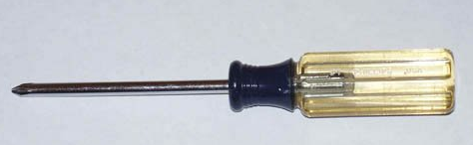
Hand Tools and Supplies

- Case and Power Supply
- Motherboard
- Processor
- CPU cooler
- Memory module(s)
- Hard drive(s), cable(s)
- Optical drive, with data cable (and audio cable, if applicable)
- Floppy drive and cable (if applicable)
- Video adapter, unless embedded
- Sound adapter, unless embedded
- Network adapter, unless embedded
- Any other expansion cards (if applicable)
- Supplementary case fan(s)
- Keyboard, mouse, and other external peripherals
- Monitor
- Screws, brackets, drive rails, and other connecting hardware

Building a PC requires at least the following components
Hand Tools and Supplies
You really don't need many tools to build a personal computer (PC). Using only our Swiss Army knife or using only a Phillips screwdriver.

However, it's helpful to have more tools, of course. Needle-nose pliers are useful for setting jumpers. A flashlight is often useful, even if your work area is well lit. A 5mm (or, rarely, 6mm) nut driver makes it faster to install the brass standoffs that support the motherboard. A larger assortment of screwdrivers can also be helpful.

HAZARD AND SAFETY
Surge (or spike): a very brief, abrupt change in voltage.
Sags: a brief dip in available voltages (e.g. caused by many power-up once)
Brownouts: an extended sag (over a second)
Blackout: complete loss of power.

High voltage equipment and laser device should not be serviced without specific training. This includes Cathode Ray Tube (CRT), Power Supplies, Laser (high power light sources). Hazardous materials inside your PC include battery, toner kits and cartridge.

THE COMPUTER CASE
The case (or chassis) is the foundation of any system. Its purpose is to support the power supply, motherboard, drives, and other components.
A good case performs all of these tasks well is strongly built and rigid. Adding or removing components is quick and easy. All the holes line up. There are no sharp edges or burrs. A bad case is painful to work with, sometimes literally. It may have numerous exposed razor-sharp edges and burrs that cut you even if you're careful. It is cheaply constructed of flimsy material that flexes excessively. Tolerances are very loose, sometimes so much so that you have to bend sheet metal to get a component to fit, if that is even possible. Using a cheap case is a sure way to make your system-building experience miserable.

ELECTROSTATIC DISCHARGE (ESD)
Static electricity is not harmful to people, but is nasty to (and has a cumulative effect on) most of your computer components. The risk of ESD increases significantly under hot, dry conditions. Always take anti-static precautions when handling static-sensitive components like for example: memory, CPU, and hard drives.

WAYS TO PREVENT ESD
- Remove any jewelry you may be wearing, as metals are conductors of electricity.
- Do not wear clothes made of synthetic material, as this material is a good conductor of charge.
- Wear shoes with rubber soles to get rid of static charge.
- Ensure that the carpets are dust-free.

ANTI-STATIC PRECAUTIONS
ESD Packaging, ESD strap and Grounding Cords/Plugs, Conductive Mats, Anti-Static Floors/Carpets, Humidifier, Temperature Control.

POWER SUPPLY
The power supply is one of the most important components in a PC. In addition to providing reliable, stable, closely-regulated power to all system components, the power supply draws air through the system to cool it.

A marginal or failing power supply can cause many problems, some of which are very subtle and difficult to track down. Most problems are not subtle, however. A poor or marginal power supply is likely to cause system crashes, memory errors, and data corruption, and may fail catastrophically, taking other system components with it.

POWER SUPPLY CONNECTOR
The below illustration is the typical female connector which would be used to connect to a device such as a CD-ROM or Hard Drive. This connector is referred to as a large molex connector. Additional to these types of connectors you may also find a small molex which is generally used for the floppy disk drive.

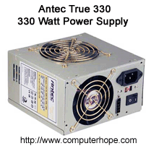

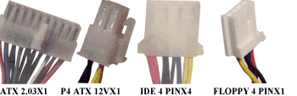

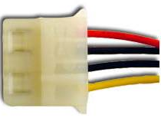
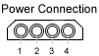

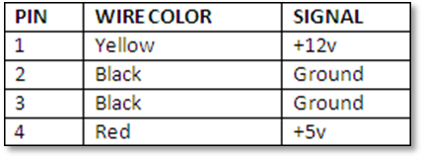
POWER SUPPLY FUNCTION
Supplies power throughout the computer. Power supplies convert potentially lethal 110-115 or 220-230 volt alternating current (AC) into a steady low-voltage direct current (DC) usable by the computer. A power supply is rated by the number of watts it generates.

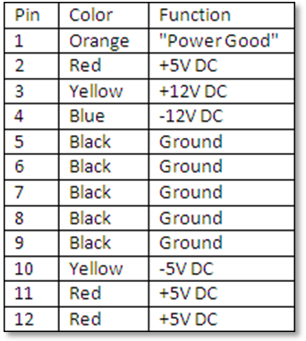

POWER SUPPLY FORM FACTORS
Currently in the industry there are eight power supply form factors. Each of these form factors can have various amounts of configurations and power output levels.
PC / XT, LPX, AT/Desk, ATX, AT/Tower, NLX, Baby AT and SFX

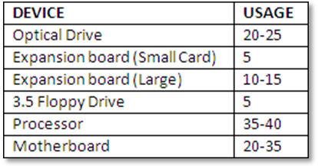
warning
Do not open the power supply; it contains capacitors which can hold Electricity (WHICH CAN KILL) even if the computer is power off for a week, if not longer.

The power supply does exactly what its name suggests: supplies power to the rest of the components in the computer. The power supply takes 120 volts or 240 volts (depending on the country you are in) from your building and converts it to output ranging from 5 volts down to 1.5 volts. It contains a number of leads that supply different voltages for different types of devices (such as floppy drives and hard drives).
what type of power adapter or converter do i need?

Depending on the country you are visiting and the type of computer you are using will affect the type of adapter you need. Many desktop computers and some laptop computers and other portable computers have a switch that enables the power supply to convert between multiple voltages.

For example, a power supply may enable a user to convert between 115V and 230V. If the country you are visiting supports the alternate voltage, you may only need to purchase a power adapter that enables your plug to connect to a different type of power plug. If your computer does not support the voltage of the country you are visiting, you will need to purchase a voltage converter capable of converting the voltage of the country you are visiting to the voltage of your computer.

POWER IN DIFFERENT COUNTRIES
Several new desktops and laptops have the ability to auto switch allowing the power supply to automatically adjust to the correct power settings. It is also important to remember that different countries generally have different plugs and your computer or laptop manufacturer may require a special plug or adapter.

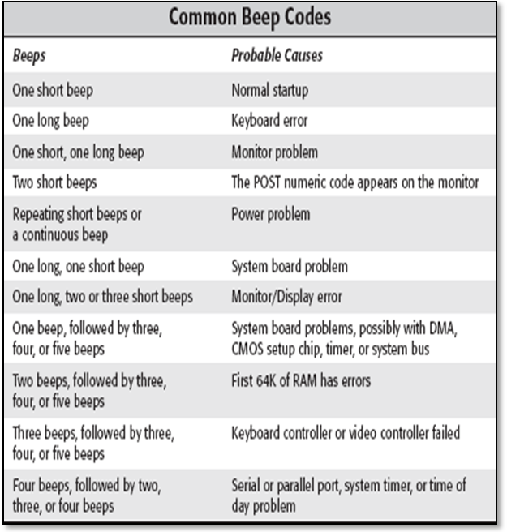
POWER SUPPLY WATTAGE
You can determine the total output of a power supply by physically examining the power supply. All power supplies have a sticker on the power supply that gives all important specifications, including the total output of the power supply. For example, this power supply would list the total output as 330W (330 Watt power supply).

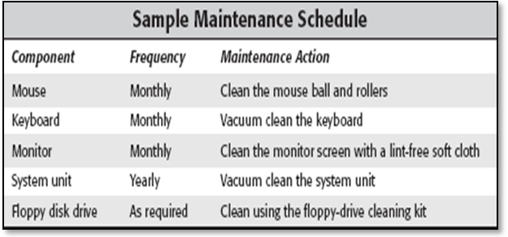
recommended POWER SUPPLY CAPACITY
Size your power supply according to the system configuration. For an entry-level system, install a 300W or larger power supply. For a mainstream system, install a 400W or larger power supply. For a high-performance system, install a 500W or larger power supply.

